УДК 004.6, 004.89

Weighted coherence as topic models’ interpretability measure
Zhgutov K. D., Alekseev V. A., Vorontsov K. V.
Moscow Institute of Physics and Technology

Topic modeling is a text data analysis method that automatically identifies hidden topics in large collections of text data. Topic models are used in information retrieval, documents’ categorization, social networks’ data analysis, recommendation systems, exploratory search and other areas not related to texts.
Interpretability is a key characteristic of an useful topic model. But interpretability of the topic model is a poorly formalized requirement. Informally, it means that according to the lists of the most frequent words of the topic, the expert can understand what this topic is about and give it an adequate name. Expert approaches are necessary at the research stage, but they make it difficult to automatically build good topic model.
It was previously shown [2] that among the quality criteria calculated automatically from a collection, coherence or consistency correlates best with expert estimates of interpretability. However, the existing methods for calculating coherence have a “fundamental limitation” [1]. These methods consider the distribution of only a small subset of words, resulting in a significant loss of accuracy. As an alternative, an approach known as Intra-text coherence has been proposed [1], which considers all words but rejects the concept of PMI.
This study aims to enhance coherence calculation techniques by investigating new quality criteria for topic models that incorporate both the distribution of topics across the text and the concept of PMI as a measure of word coherence. The research compares these new criteria with existing methods and proposes a methodology for assessing the interpretability of topics.
This work introduce an alternative method of topic model’s interpretability measuring. As computational experiment shows, metrics that based on weithed coherency demonstrate a higher correlation with the consistency of word chains compared to the traditional top word coherence [Table 1].
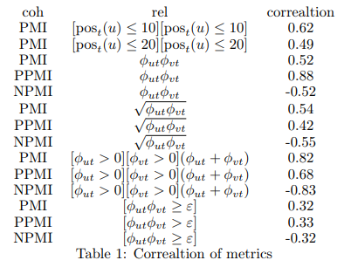
References
[1] Vasily A Alekseev, Vladmir G Bulatov, and Konstantin V Vorontsov. Intra-text coherence as a measure of topic models’ interpretability. In Komp’juternaja Lingvistika i Intellektual’nye Tehnologii, pages 1–13, 2018.
[2] David Newman, Jey Han Lau, Karl Grieser, and Timothy Baldwin. Automatic evaluation of topic coherence. In Ron Kaplan, Jill Burstein, Mary Harper, and Gerald Penn, editors, Human Language Technologies: The 2010 Annual Conference of the North American Chapter of the Association for Computational Linguistics, pages 100–108, Los Angeles, California, June 2010.

